**Table 1.** Description of the five intervention scenarios.

|  |  |  |
| --- | --- | --- |
| Scenario | Description of *c(t)* | Definition of *c(t)* |
| 1 | Immediate and constant reduction to *cmin*. |  |
| 2 | Immediate reduction to *cmin* followed by a linear increase back to *c(t)* = 1. | $$c(t)=c_{min}+\frac{1-c_{min}}{d_{t}}(t-t_{p})$$ |
| 3 | Linear decrease to *cmin* followed by an immediate return to *c(t)* = 1. | $$c(t)=1-\frac{1-c_{min}}{d_{t}}(t-t_{p})$$ |
| 4 | Linear decrease to *cmin* at *dt*/2, followed by a linear increase back to *c(t)* = 1. | $$c(t)=\left\{\begin{aligned}1-\frac{1-c_{min}}{\frac{d_{t}}{2}}(t-t_{p}), &t_{p}≤t<t_{p}+\frac{d_{t}}{2} \\ c_{min}+\frac{1-c_{min}}{\frac{d_{t}}{2}}(t-t_{p}), &t_{p}+\frac{d_{t}}{2}≤t≤t_{p}+d_{t}\end{aligned}\right.$$ |
| 5 | A “pulsing” intervention with immediate reductions to *cmin* between intervention intervals 0-21, 35-49 and 63-77 days (for an example total intervention duration, *dt* = 84 days). | $$c(t)=\left\{\begin{aligned}c_{min}, &t_{p}≤t<t_{p}+{\frac{1}{6}d}_{t} \\ 1, &t_{p}+\frac{1}{6}d_{t}≤t<t_{p}+\frac{2}{6}d_{t} \\ c_{min}, &t_{p}+\frac{2}{6}d_{t}≤t<t_{p}+{\frac{3}{6}d}_{t} \\ 1, &t_{p}+\frac{3}{6}d_{t}≤t<t_{p}+{\frac{4}{6}d}_{t} \\ c_{min}, &t_{p}+\frac{4}{6}d_{t}≤t<t_{p}+{\frac{5}{6}d}_{t} \\ 1, &t≥t_{p}+{\frac{5}{6}d}_{t}\end{aligned}\right.$$ |

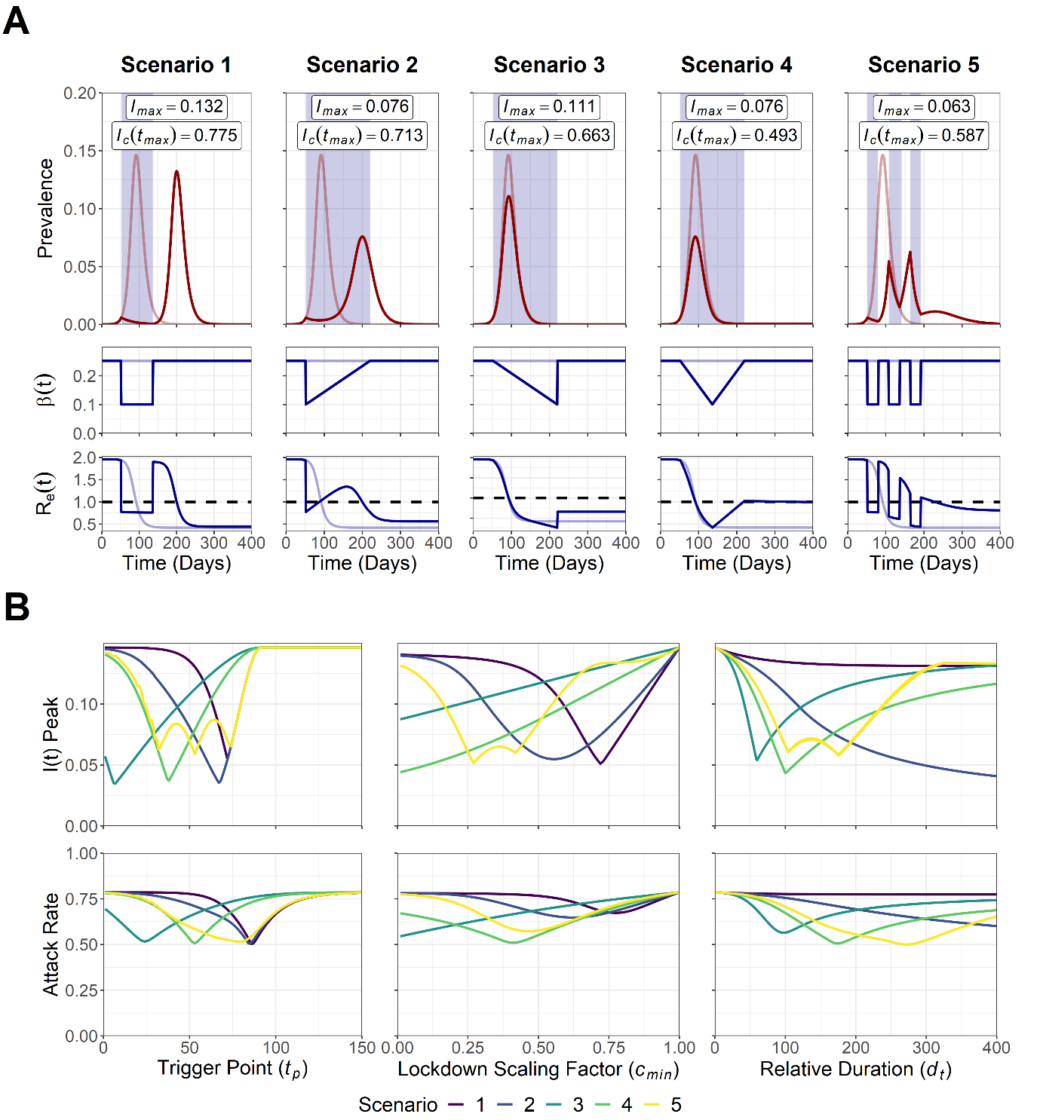

**Figure 1. A) Trajectory plots for the epidemic curve, *β(t)* reductions and *Re(t)* for the five intervention scenarios. B)** **Sensitivity analysis for intervention trigger point (*tp*), magnitude (*cmin*) and duration (*dt*) to minimise the peak prevalence, *Imax*, and attack rate, *Ic(tmax)*.** For A) pale red and blue lines depict unmitigated epidemic curve dynamics,blue shading indicates the intervention period and the dotted line depicts the *Re(t)* = 1.0 threshold for sustained epidemic growth. *Imax* and *Ic(tmax)* values are annotated for each scenario.Note that for B) the *dt* axis for scenario 1 was transformed into a relative axis to allow for comparison across scenarios, with the relative axis of 0 ≤ *dt* ≤ 400 being equal to an absolute *dt* range of 0 ≤ *dt* ≤ 200.

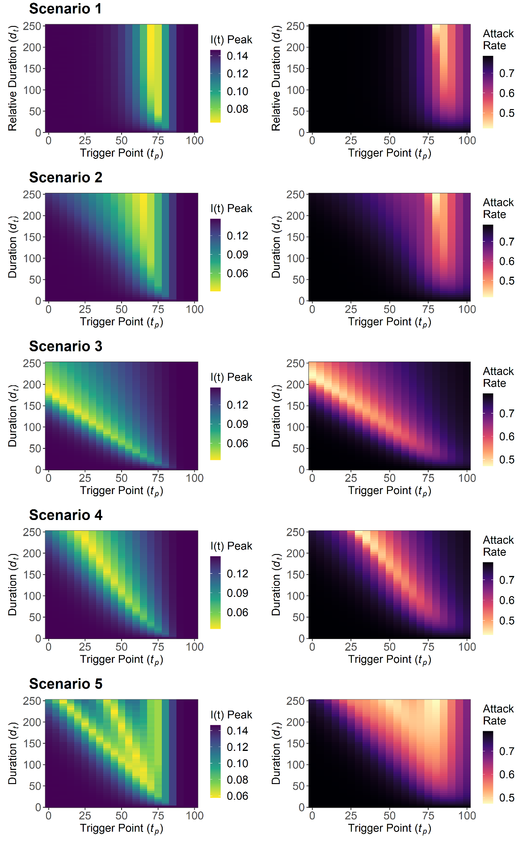

**Figure 2. Sensitivity analysis for the peak prevalence, *Imax*, and attack rate, *Ic(tmax)*, for intervention trigger point, *tp*, and duration, *dt*.** Note that the scenario 1 *dt* axis was transformed into a relative axis to allow for comparison across scenarios, with the relative axis of 0 ≤ *dt* ≤ 250 being equal to an absolute *dt* range of 0 ≤ *dt* ≤ 125.

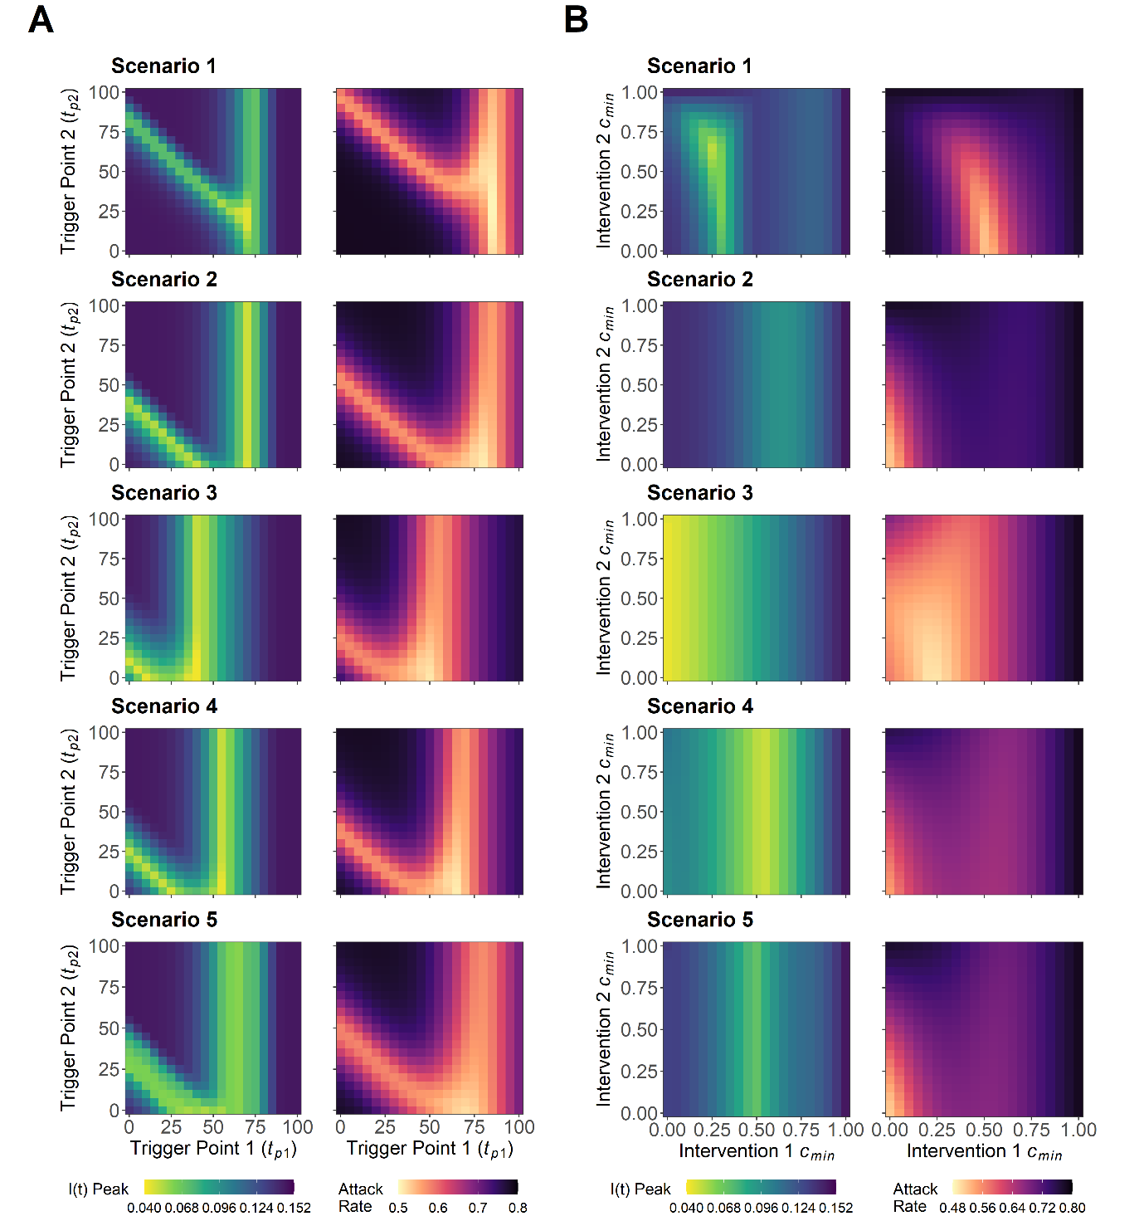

**Figure 3. A) Sensitivity analysis for the peak prevalence, *Imax*, and attack rate, *Ic*(*tmax*), for intervention 1 trigger point, *tp1*, and intervention 2 trigger point, *tp2*. B) Sensitivity analysis for the** **minimum value of scaling factor *c(t)* for intervention 1, *cmin1*, and intervention 2, *cmin2*.**